Project: SkillSphere – AI-Driven Career Readiness and Personalized Learning Recommendation Platform
AI -Driven Career Readiness Platform
Submitted in the partial fulfilment for the Course of
CSA1012 – SOFTWARE ENGINEERING
to the award of the degree of
BACHELOR OF TECHNOLOGY
IN
COMPUTER SCIENCE(AI)
Submitted by
R.Jalaja (192525365)
Under the Supervision of
DR ANITADAVAMANI K
SIMATS ENGINEERING
Saveetha Institute of Medical and Technical Sciences
Chennai-602105
Aug -2026

1. Project Overview
SkillSphere is an AI-driven career readiness platform designed to help students understand their skills, identify skill gaps, and receive career-oriented recommendations. The project demonstrates full-stack development, version control using Git and GitHub, and containerized deployment using Docker and Docker Compose.
The implemented project contains a Node.js/Express backend and a frontend served through Nginx. Docker Compose runs the backend and frontend as separate services.

2. Problem Statement
Students need a simple way to understand their current technical skills, identify missing skills for a target career, and receive suitable learning or career recommendations. SkillSphere provides a structured platform to organize and present this information.

3. Objectives
- Develop a web-based SkillSphere career readiness application.
- Provide backend APIs for student, skill-gap, and recommendation functions.
- Create a simple frontend interface.
- Use Git and GitHub for version control.
- Use Docker to package the application into portable containers.
- Use Docker Compose to run frontend and backend together.

4. Main Features and Modules
- Student Management Module
- Skill Gap Module
- Recommendation Module
- Frontend Interface
- Backend REST API
- Containerized Deployment

5. Technology Stack
- Frontend: HTML, CSS and JavaScript.
- Backend: Node.js with Express.
- Web Server: Nginx.
- Version Control: Git and GitHub.
- Containerization: Docker.
- Multi-container orchestration: Docker Compose.

6. Project Structure
The SkillSphere repository is organized into backend, frontend and documentation-related files. The backend contains controllers, models, data, routes and the server. The frontend contains the application page, JavaScript and CSS. Dockerfiles are provided for both services, while docker-compose.yml manages the services.

Project Folder Structure
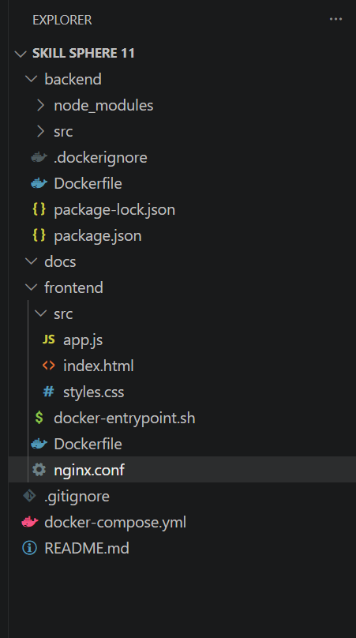

7. Backend Development
The backend is implemented using Node.js and Express. Controllers support student management, skill-gap analysis and recommendations. Dependencies are managed using package.json and package-lock.json. The backend is packaged using backend/Dockerfile.

Backend Dependency Installation
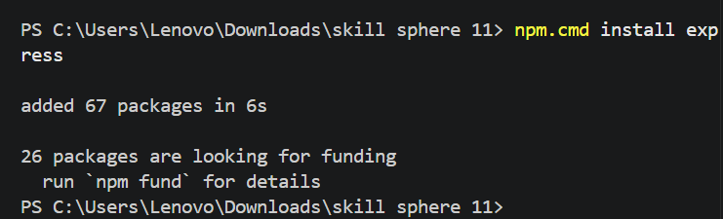

8. Frontend Development
The frontend provides the user interface. The main page is in frontend/src/index.html, JavaScript is in frontend/src/app.js, and styling is in frontend/src/styles.css. Nginx serves the frontend.

Frontend Files or Code
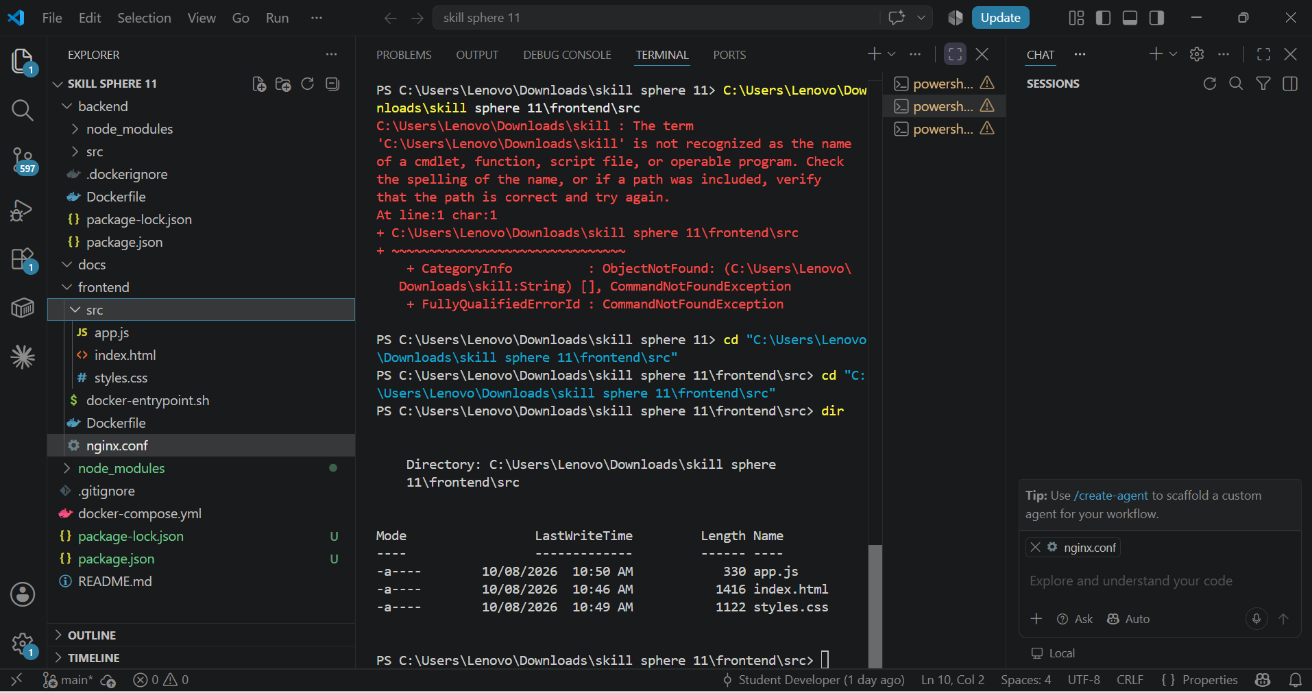

9. Git Version Control
Git was used to track the SkillSphere source code. Files were staged and committed on the main branch. Git status was used to verify the final clean working tree. The project was connected to GitHub through the origin remote.

10. GitHub Repository
The SkillSphere project was pushed to the GitHub repository associated with the Jalaja365 account. GitHub stores the project source code and version history.

GitHub Repository
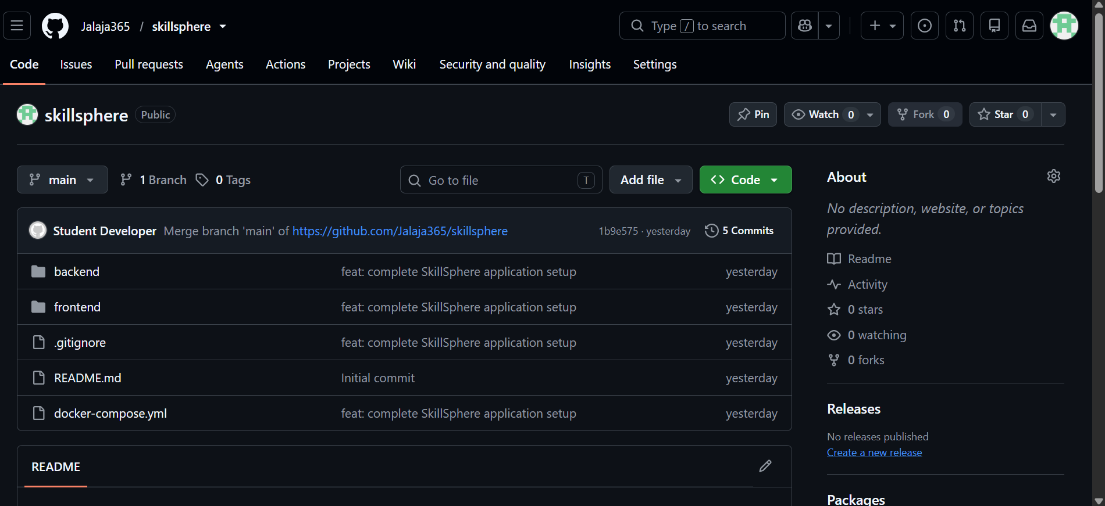

Final Git Status
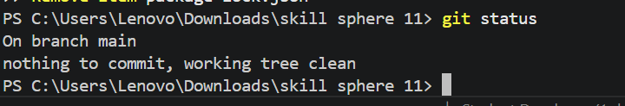

11. Docker Containerization
Docker was used to containerize the SkillSphere application. Separate Dockerfiles are available for the backend and frontend. Containerization provides a consistent and portable environment for running the application.

12. Docker Compose
Docker Compose manages the SkillSphere frontend and backend services together. Both services can be started with one command.

Docker Compose Startup
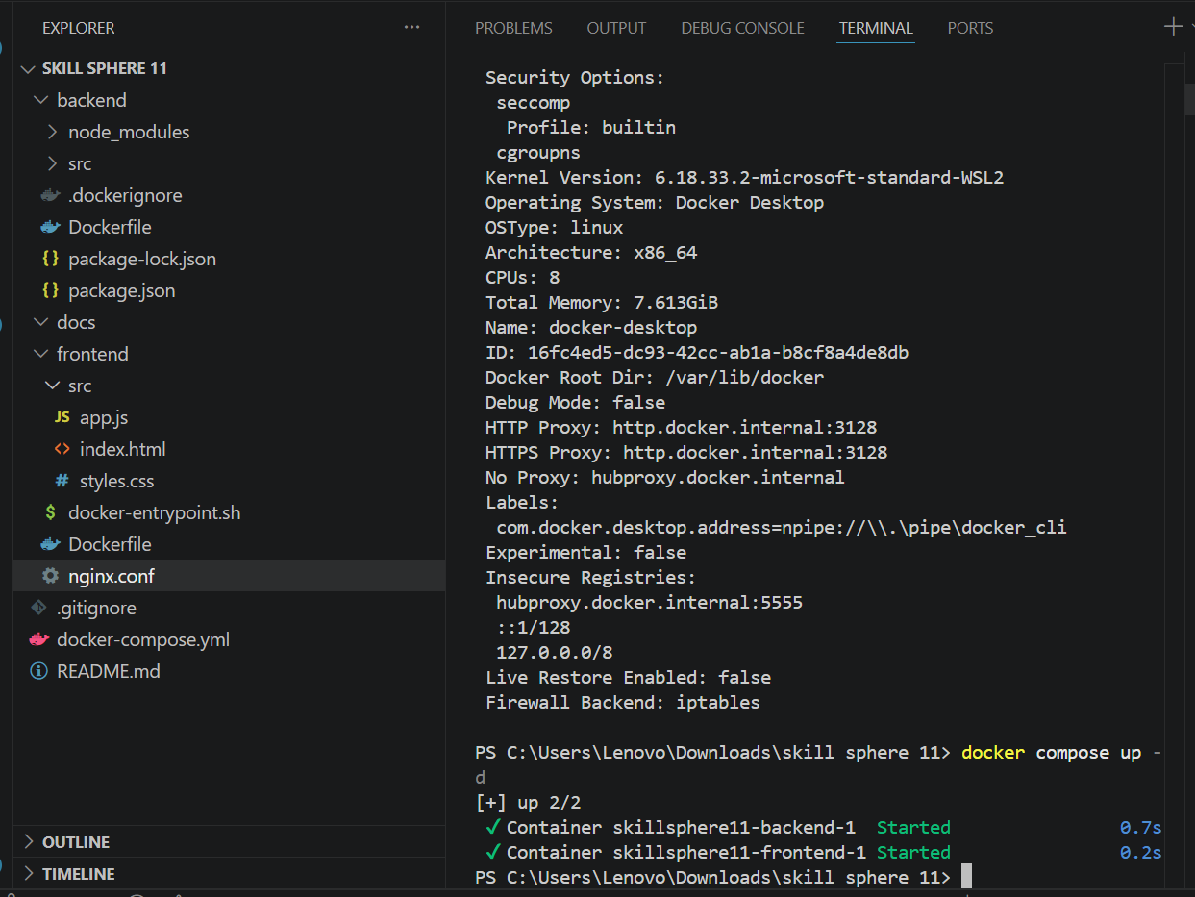

Docker Compose Status
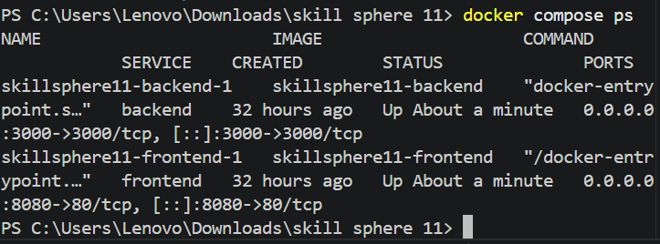

13. Running the SkillSphere Web Application
After the Docker services are started, the SkillSphere frontend can be accessed locally through a web browser at http://localhost:8080.

Working SkillSphere Web Application
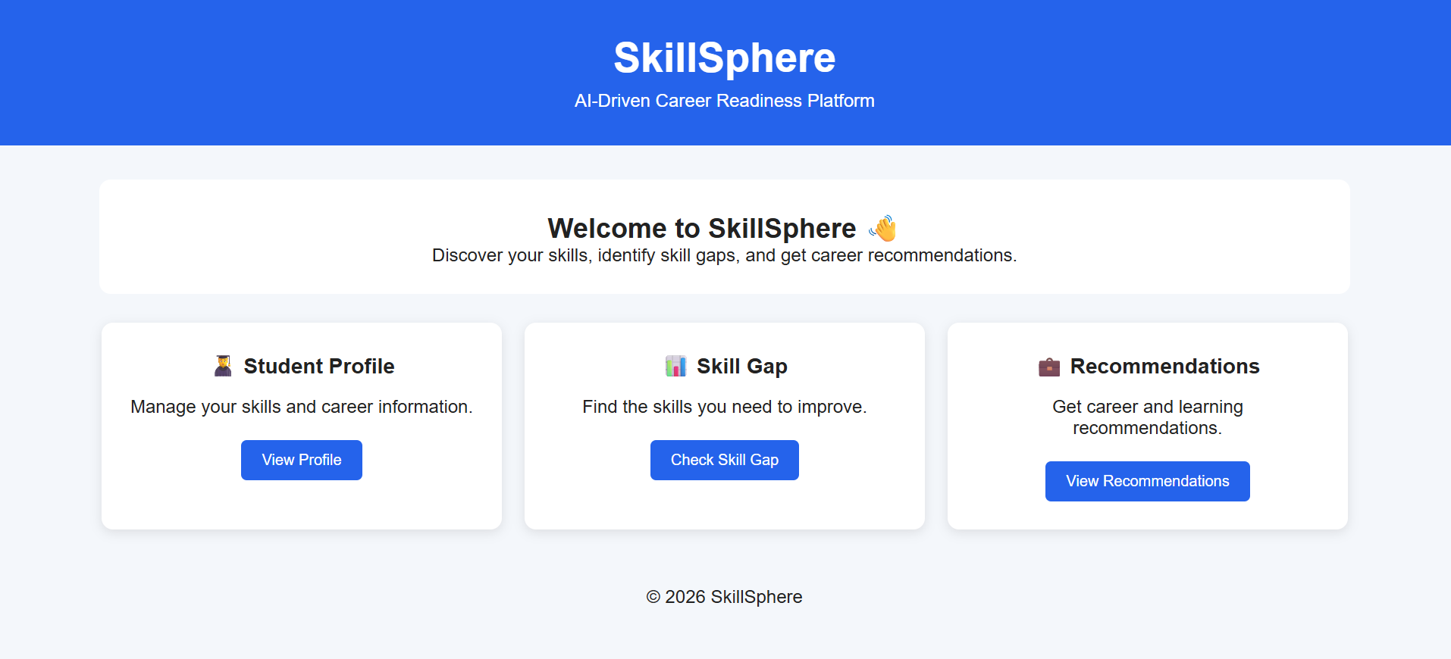

14. Testing and Verification
- Verified Node.js and npm availability using npm.cmd.
- Verified Express installation.
- Verified Docker and Docker Compose.
- Built frontend and backend images.
- Started both services using docker compose up -d.
- Verified containers using docker compose ps.
- Opened the application through localhost:8080.
- Verified Git status after committing changes.

15. Results
The SkillSphere application was successfully organized as a full-stack project and containerized using Docker. The frontend and backend services were started together using Docker Compose, and the application was accessible locally through the browser.

16. Advantages
- Portable deployment through Docker.
- Simple multi-service management with Docker Compose.
- Version control through Git.
- Remote source-code storage through GitHub.
- Clear separation of frontend and backend.
- Easy deployment verification.

17. Limitations
- Current setup is mainly for local/development deployment.
- Advanced AI recommendation capabilities can be expanded.
- Persistent database integration can be added.
- Authentication and role-based access can be enhanced.

18. Future Scope
- Integrate a production database.
- Add authentication and role-based access.
- Improve AI-based career recommendations.
- Add dashboards and progress visualization.
- Add cloud deployment and CI/CD.
- Add automated testing.

19. Conclusion
SkillSphere demonstrates full-stack development together with modern software engineering practices. Git and GitHub provide version control and project history, while Docker and Docker Compose provide a consistent deployment environment. Successful container execution and access through localhost confirm the project setup.

20. References
- Git documentation.
- Docker and Docker Compose documentation.
- Node.js and Express documentation.
- Nginx documentation.
- SkillSphere project source files.

